REPORT DOCUMENT

**App Name:** Book-A-Hostel

**App description:** App for booking hostel

**App designers:**

Daniel Olugbenro (2002371)

Charles Nkanga (1508255)

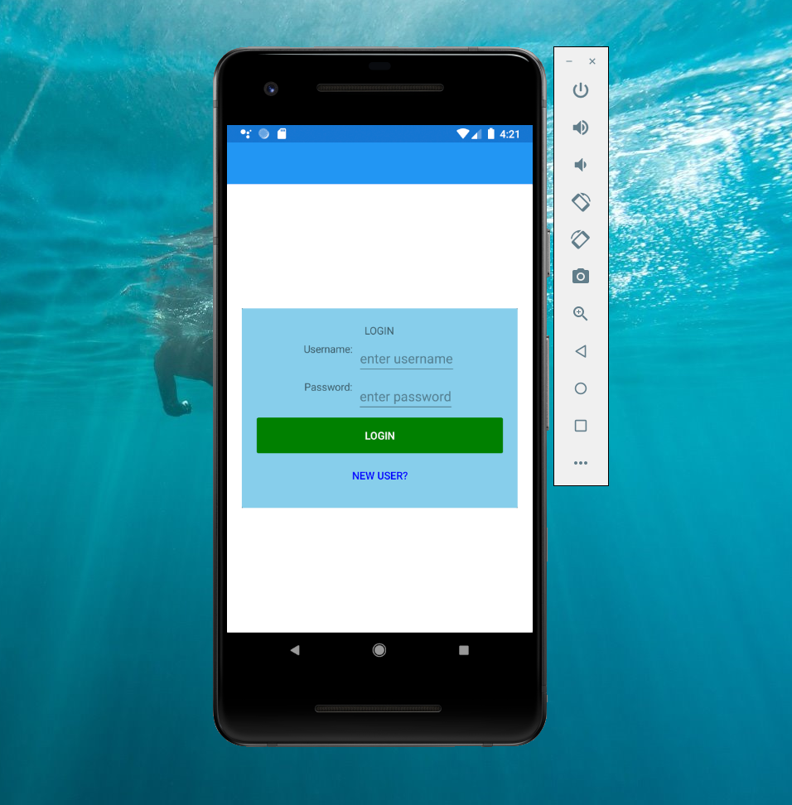Login Page:

The Login Page

App opens with the login page. Default credentials are password = password and username = username for testing purposes.

Two buttons are present; The login page which upon correct entry directs the user to the main page.

And the New User button takes the user to the registration page.

Registration Page:

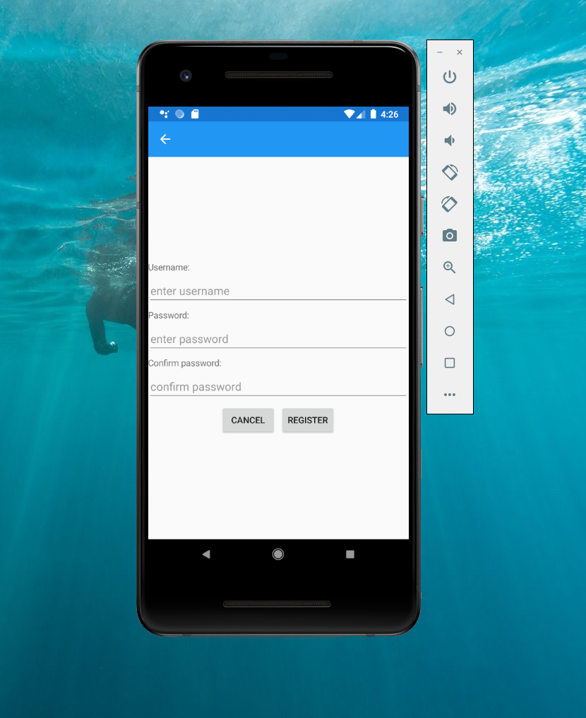

The registration Page

The registration page allows new users to enter credential and redirects them to the login page after successful registration.

Apply Page (House Page):

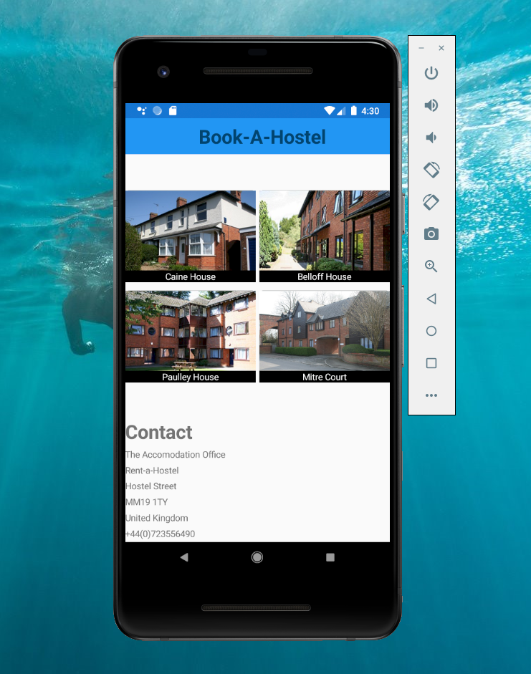

The page contains image buttons of each hostel/house building. When clicked would direct the user to a page showing the description of each house e.g. location and types of room that are present in each building. It also features contact information if the user requires any info or help from the accommodation office. It is a scrollable view.

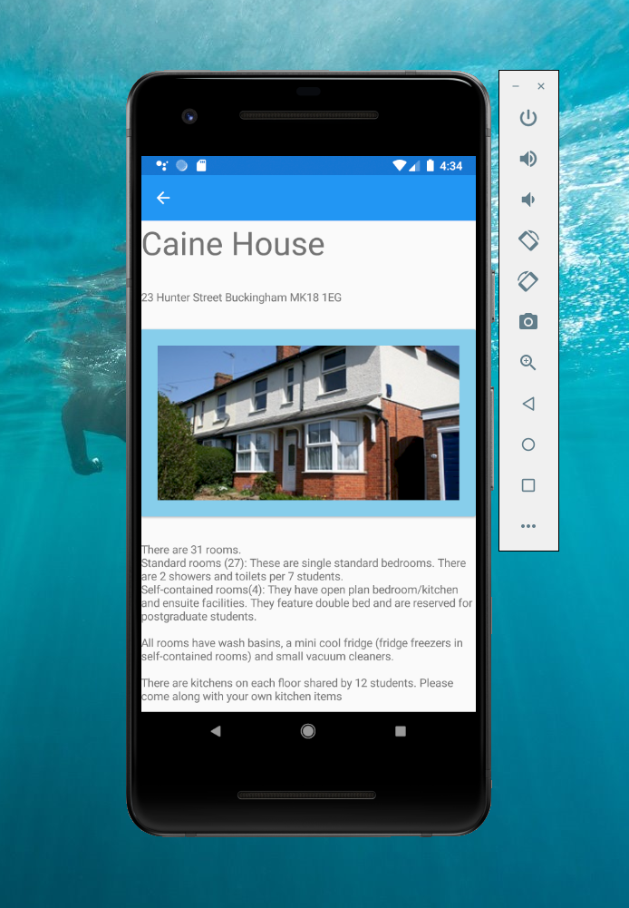House info page:

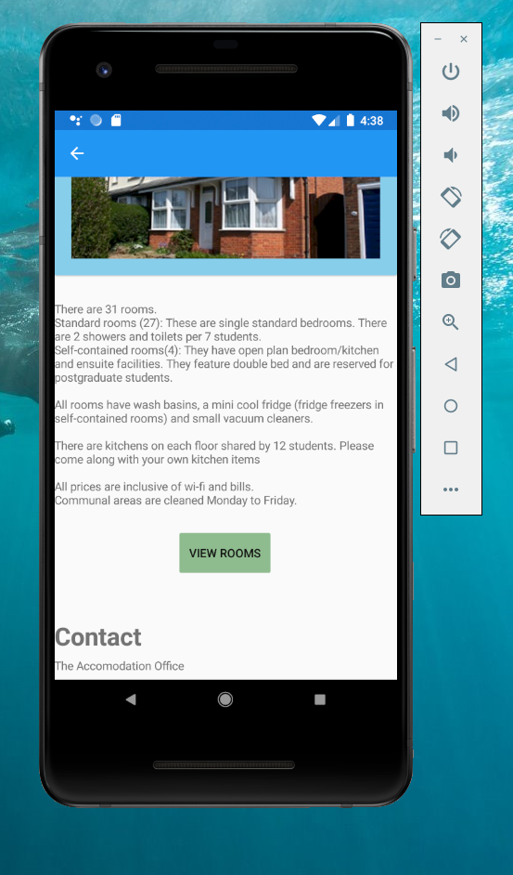

The house info page contains general information about each house /building, the location, services available etc. It is a scrollable view.

The view rooms button takes the user to a page showing the rooms that each house contains and info.

The Rooms Page:

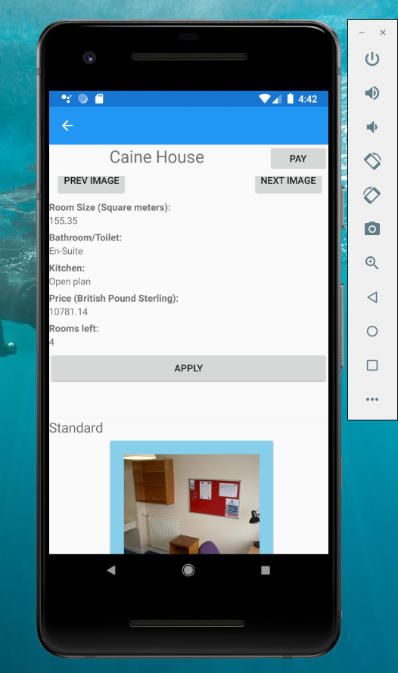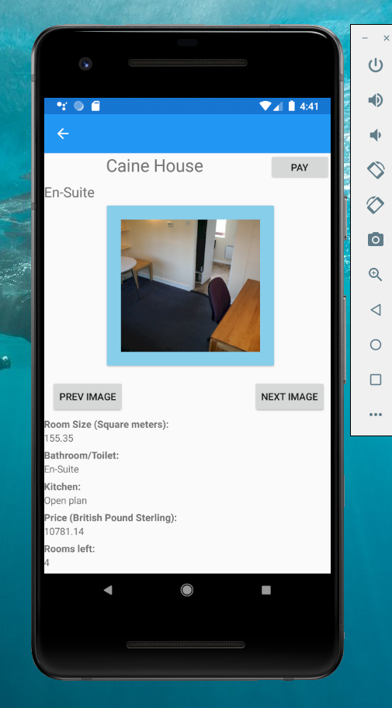

The Rooms info page contains info about all the rooms in each house. This includes images that can be scrolled through with the prev image and next image buttons, room size, type of bathroom and kitchen and price.

This page also features an apply button for each room that adds a user’s selection to a list/cart and users are allowed to book multiple rooms.

Selecting one room multiple times will prompt a user with a warning. User can make multiple applications.

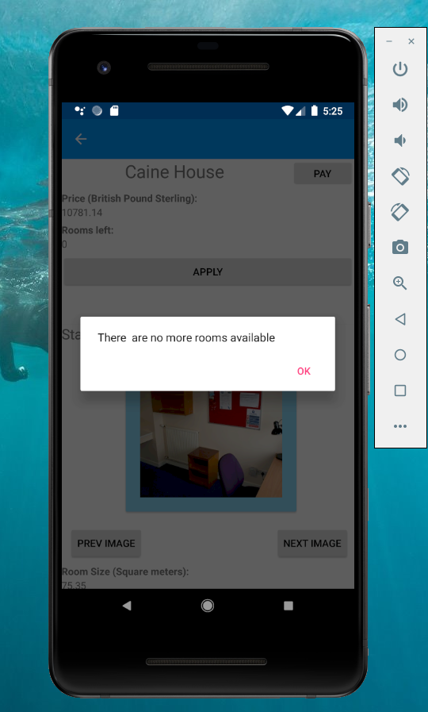

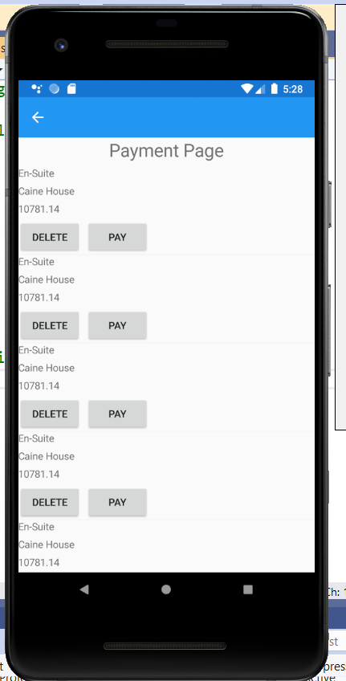Payment page:

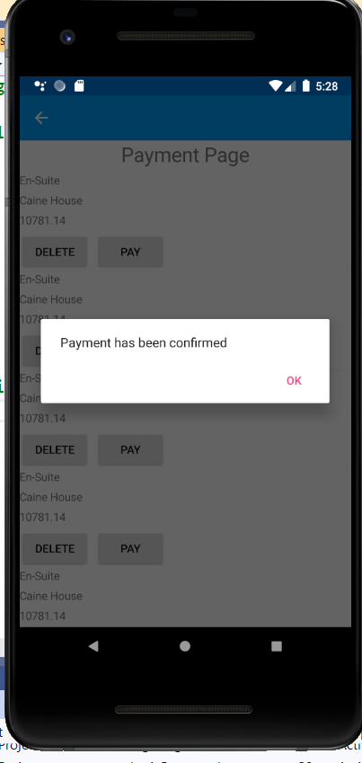

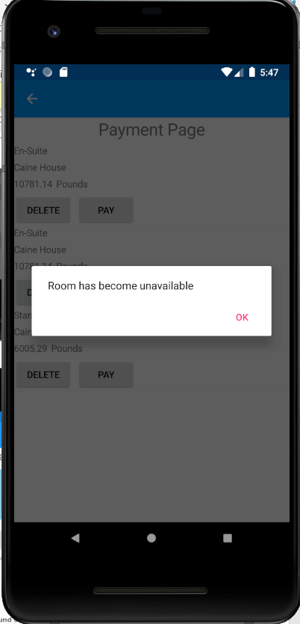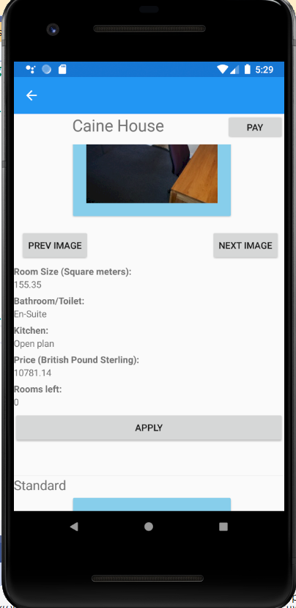

The payment page has two buttons for each item or room applied for on each row.

The pay button allows the user to pay for a single room. It also edits the number of rooms left to reduce by -1 and is reflected when the user goes back to the previous page (i.e. room info page). It also allows the user to make confirmation before final payment. If the number of rooms (i.e. count) goes below 1, a message is projected on the screen to tell the user that the room is unavailable, and that entry is removed from the payment page.

The delete button allows the user to remove an entry for a room by deleting the content of that row.

If the page becomes empty either, it automatically navigates the user to the previous page.